UML CLASS DIAGRAM

A diagram that show the structure of a system by showing the classes, attributes, operations/methods, and their relationships.

Parts to know

Classes- made up of states(fields) and behaviors(or methods)

Boxes in the diagram have three parts
Top – containing name
Middle- attributes of the class
Bottom – methods the class can execute

Class item visibility-
+ Public, accessible to all
# Protected
~ Package or Default, Can be called by classes within its package
- Private, other items in the same class can access

Multiplicity-
Lets you show more detail for groups of objects
set number[1..10]
Unknown Number [*]

CLASS DEPENDENCE

Dependency-
Loosely coupled
shown by dotted line with arrow

Association-
Directly related or tightly couple
shown by solid line

Composition and aggregation-
Aggregation- ex. Human --- Race
There are other other objects that can describe humans like gender

Composition- Humans have a race, Human owns the Race attribute

Inheritance
Subclass is created from another class

Constraints
Preconditions – must be true before
Postcondtions – must be true after

Example from the internet--

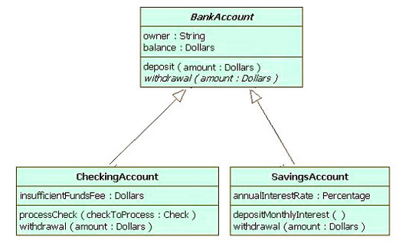

SOURCES:
https://en.wikipedia.org/wiki/Class_diagram
https://www.youtube.com/watch?v=3cmzqZzwNDM

